

## Topic: Document Content IDs

There may be times you will be asked to provide a document’s Content ID, such as when discussing a document with a colleague, and you want to share the ID so they can view the specific document. Or, perhaps on the off chance you need to contact the IT Service Center with a document issue. Providing the Content ID for the specific document(s) you are having trouble with can help IT more quickly research the issue.

Every document loaded in theSource has a unique Content ID. The Content ID is located within the Information icon. 

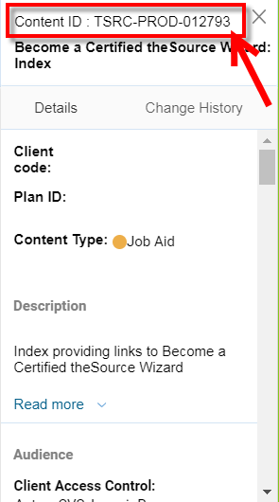

**Bonus!** The Information icon also provides information about the document, such as Description, Audience, Classifications, and Change History.

**The Information icon can be accessed from 2 locations:**

* From Search Results page, located to the far right of a document title.

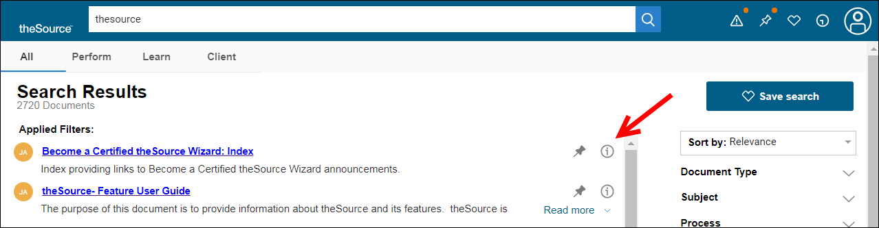

* From inside a document, at the bottom right of the page.

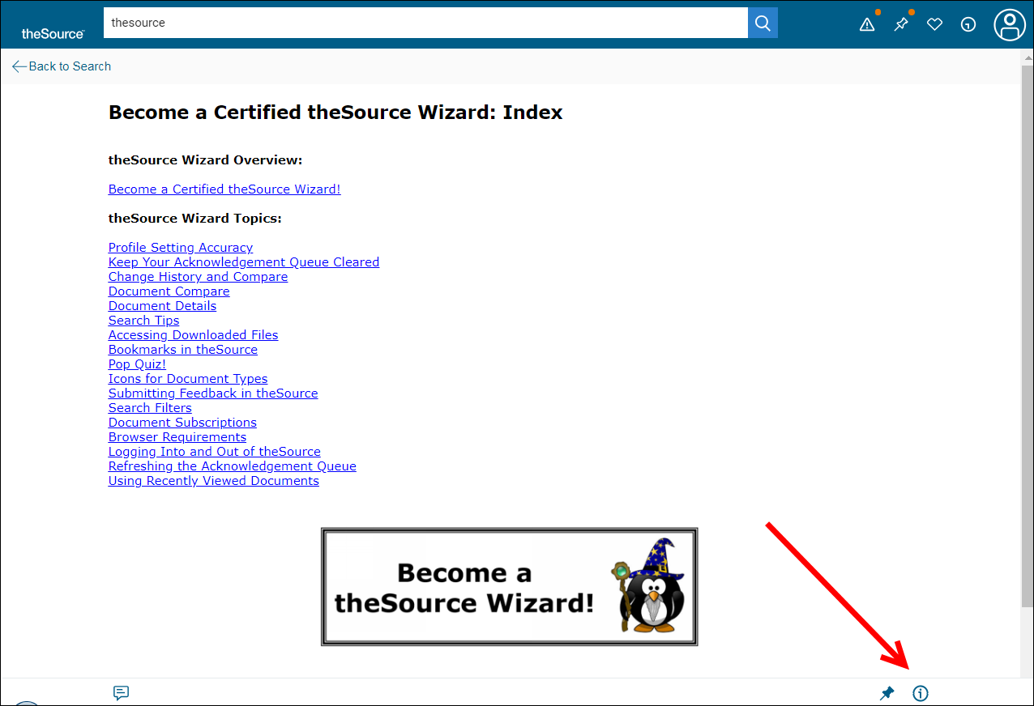

 Your next challenge on the quest to becoming a Certified theSource Wizard is to access the Information icon to locate a document’s Content ID the next time you need to share information about a specific document.

Additional resources:

* Become a Certified theSource Wizard: Index

Not to Be Reproduced or Disclosed to Others without Prior Written Approval

**ELECTRONIC DATA = OFFICIAL VERSION / PAPER COPY = INFORMATIONAL ONLY**